**Create IBM Watson Platform and Devices**

Team id: PNT2022TMID23926

Project Name: Iot Based Smart Crop Protection System

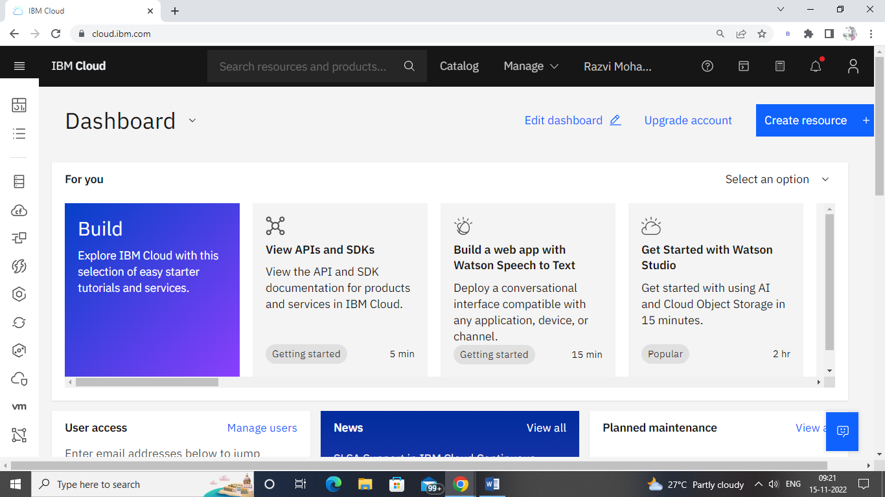step 1 : open a IBM cloud account

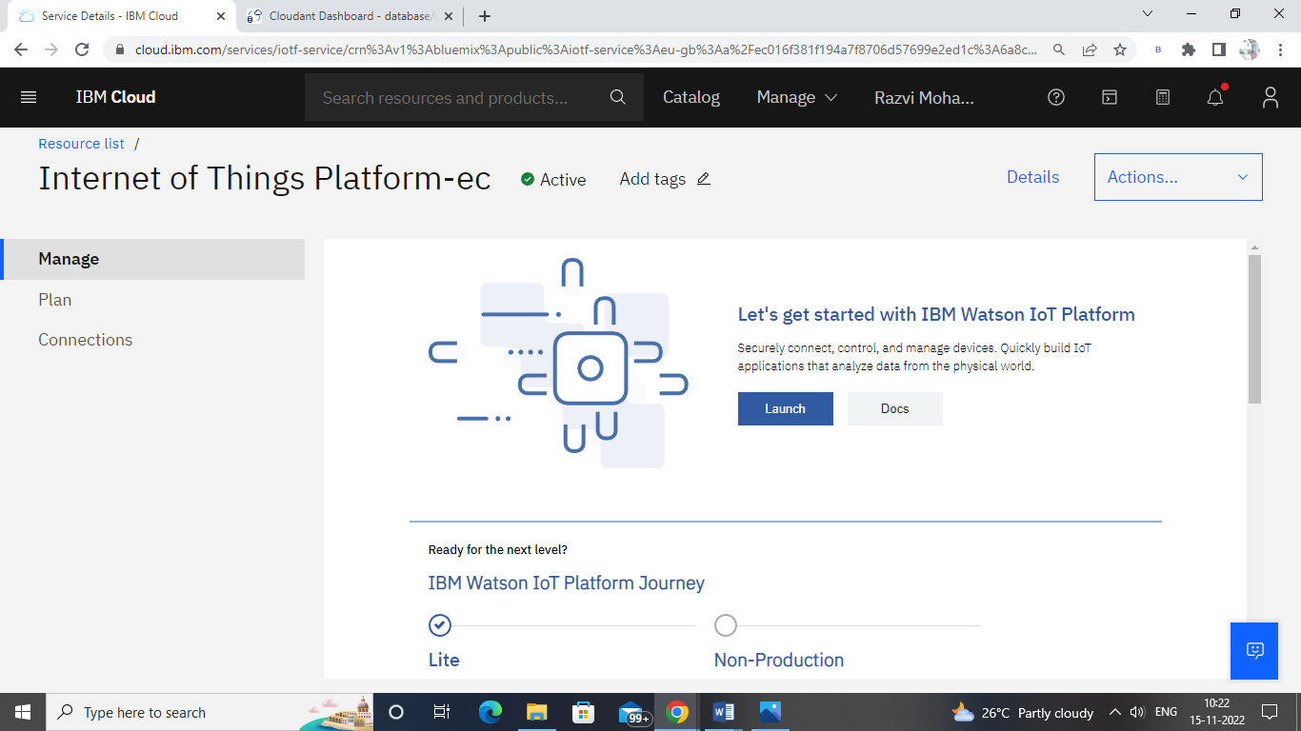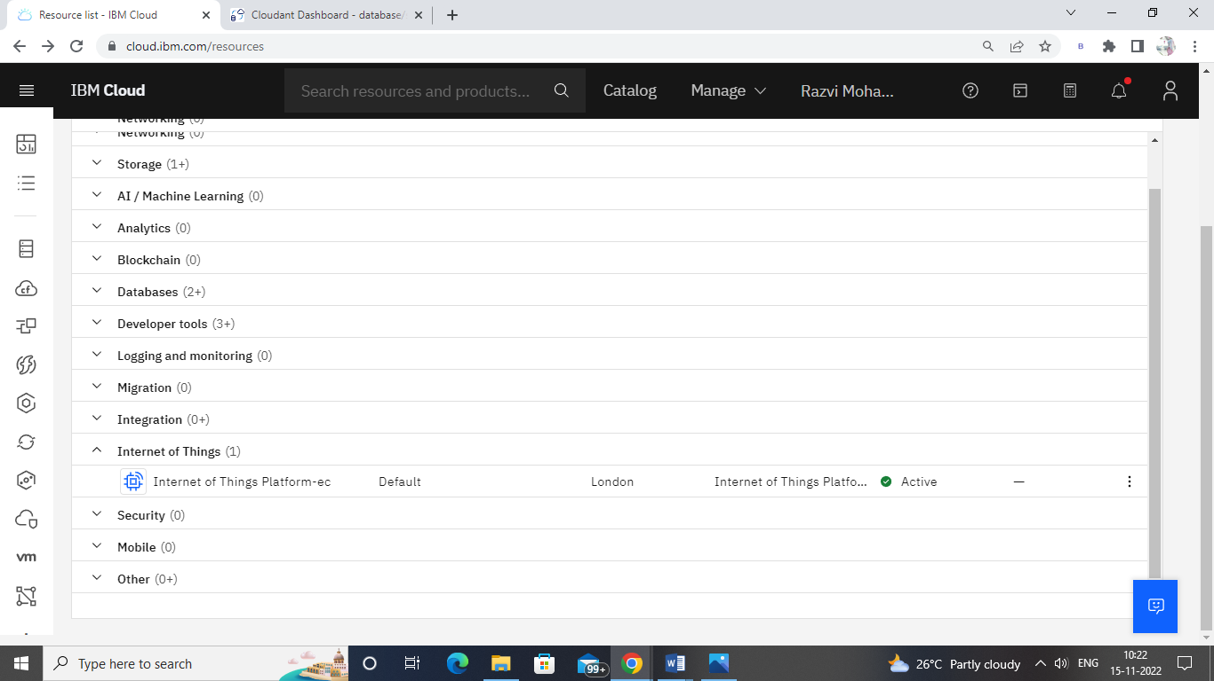step 2 : Click the Resources list and choose the Internet of Things then open it.

Step 3 : Now able to see the Watson IOT Platform then launch the dashboard .

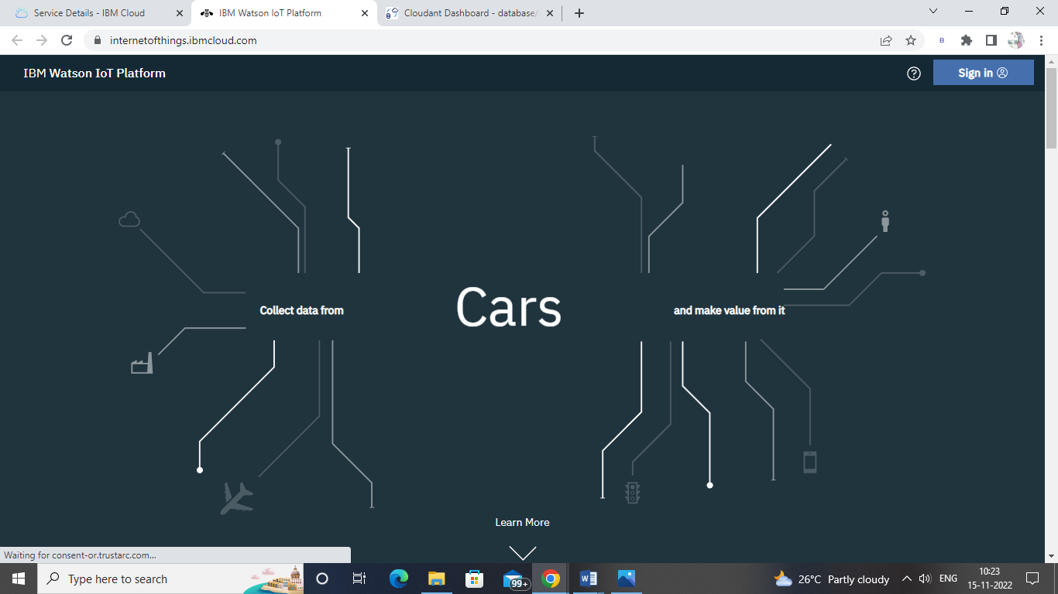step 4 : Login to the Watson IOT Platform using the same id and password while using IBM cloud.

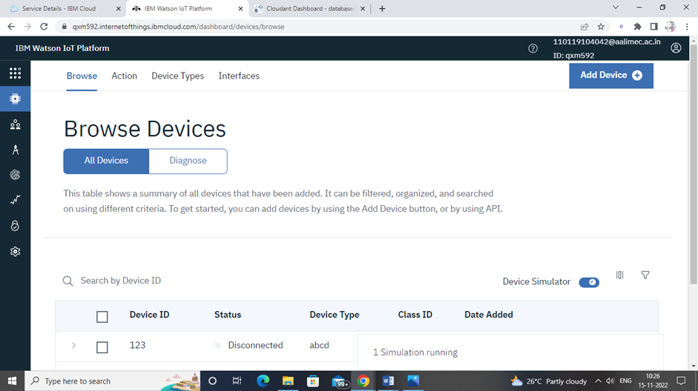

Step 5 : Now create a device in Watson IOT platform.

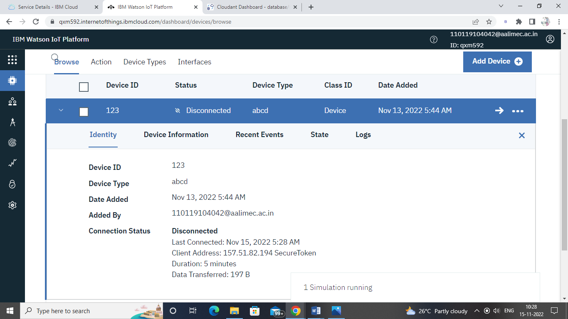Step 6 : create a device event then start simulate the device.

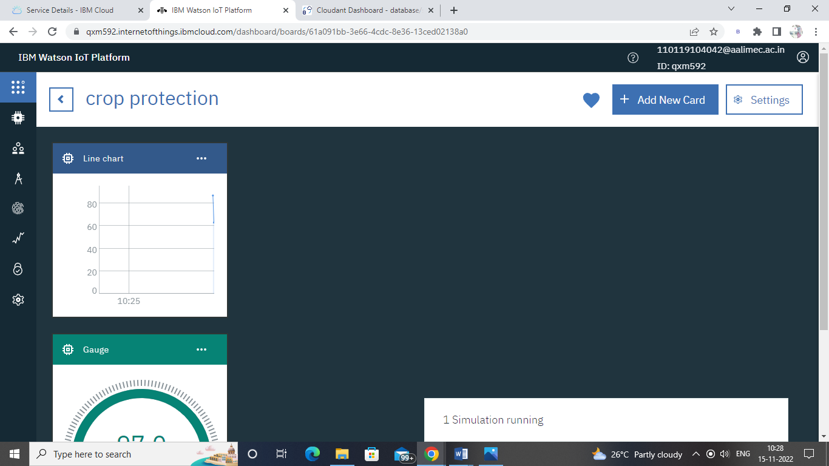

Step 7 : The Boards will display card for the project.